

ARTIFICIAL JEWELRY SALES
Submitted in partial fulfillment of the requirements

for the Vocational Course (BCA-261)
Batch (2024-2025)

Faculty Mentor: Submitted by:
Ms. Suman Singh VISHESH CHADHA
Vocational Training Mentor 04150402024

JAGAN INSTITUTE OF MANAGEMENT STUDIES
3, Institution Area, Rohini -Sector-5,
Delhi -110085



D
ECLARATION

I hereby declare that the Project titled ARTIFICIAL JEWELRY SALES
submitted partial fulfillment of the Vocational Course BCA 261 – Advanced Excel and Power BI is my original work and has not been plagiarized or reproduced from any other source.
This project has been completed under the guidance of Ms. Suman Singh and is in partial fulfillment of the requirements of the course conducted by Jagan Institute of Management Studies.
All sources of information used have been acknowledged appropriately, and I understand that any violation of academic integrity will result in appropriate disciplinary action.

Date of Submission: 25/08/2025
Place: Jims, Rohini sec-5, Delhi - 110085

Signature: ____________________ Name: VISHESH CHADHA
Student Enrolment Number: 04150402024

CERTIFICATE

This is to certify that VISHESH CHADHA has successfully completed the project titled
“ARTIFICIAL JEWELRY SALES” using Tableau & Power BI” conducted as part of the academic curriculum for the academic year 2024–25.

We commend her dedication, sincerity, and effort in acquiring practical knowledge and hands-on skills in the field of Data Analytics and Business Intelligence. This achievement reflects her ability to apply theoretical concepts to real-world scenarios with commitment and excellence

Signature_________________



ACKNOWLEDGEMENT

I would like to express my sincere gratitude to all those who supported and guided me throughout the completion of this “ARTIFICIAL JEWELRY SALES” undertaken as part of the Vocational Course BCA 261 - Advanced Excel and Power BI.
First and foremost, I extend my heartfelt thanks to Ms. Suman Singh, whose valuable guidance, encouragement, and insights were instrumental in shaping this project.
I also wish to thank the faculty and staff of Jagan Institute of Management Studies for creating a learning environment that fostered curiosity and innovation.
My appreciation also goes to my peers and friends who shared their feedback and offered support during the course.
Finally, I acknowledge the contributions of all data sources, technical platforms, and tools used in the research and execution of this project.

Signature: ____________________
Name: VISHESH CHADHA
Student Enrolment Number: 04150402024

List of Tables/Figures
LIST OF TABLES

Table No | Description | Page No
3.1.1 | Dataset of e-commerce online purchase system | 9-11
3.2.5 | Measure 1: Total Sales | 14
3.2.6 | Measure 2: Average Discount | 14
3.2.7 | Measure 3: Return Rate | 14
3.2.8 | Measure 4: Profit | 14

LIST OF FIGURES

Figure No | Description | Page No
3.2.1 | Bar chart: Sum of quantity sold by region | 12
3.2.2 | Line chart: Sales trend over time | 12
3.2.3 | Pie chart: Sale distribution by category | 13
3.2.4 | Scatter chart: Unit Price VS Quantity | 13
4.1.1 | Tableau dashboard for measures and charts | 15
4.1.2 | Power BI dashboard | 16

S.No. | Topic | Page No.
1 | Declaration | 2
2 | Certificate | 3
3 | Acknowledgements | 4
4 | List of Tables/Figures | 5
5 | - - Introduction  - - Background of the Topic  - - Objective and Scope of the Project  - - Relevance to the Project | 7-8
6 | - - Methodology  - - Data Source  - - Tools and Techniques | 9
7 | - - Data Collection & Analysis  - - Presentation of Data  - - Charts, Tables, and Interpretation | 10-19
8 | - - Findings and Observations  - – For Tableau - Dashboard with tables and Charts, Outcomes  For Power Bi-  - - Dashboard with Tables, Outcomes  - Dashboard with Charts, Outcomes | 20-21
9 | - - Conclusion and Recommendations  - - Summary of Learnings  - - Suggestions for Future Work | 22-23
10 | References | 24
11 | Annexure | 25

ARTIFICIAL JEWELRY SALES
ARTIFICIAL JEWELRY SALES
INTRODUCTION
Artificial jewelry, also known as fashion or imitation jewelry, has become a vital part of the modern accessory market. Unlike traditional fine jewelry made of precious metals and stones, artificial jewelry is crafted from a variety of cost-effective materials such as alloy, glass, beads, stones, plastic, and plated metals. This affordability, coupled with trendy designs and versatility, has made it a popular choice among consumers across all age groups.
In recent years, the demand for artificial jewelry has surged due to changing fashion trends, increased affordability, and growing interest in casual and occasion-based styling. With the influence of social media, e-commerce platforms, and celebrity endorsements, the artificial jewelry market has evolved into a competitive and dynamic industry.
This project focuses on analyzing the sales performance of artificial jewelry, identifying consumer trends, product category preferences, regional demand patterns, pricing strategies, and seasonal fluctuations. The aim is to extract meaningful insights that can support business decisions related to inventory management, marketing strategies, and customer targeting.

  - – Background of ARTIFICIAL JEWELRY
Artificial jewellery, also known as imitation or fashion jewellery, refers to ornaments made from inexpensive materials designed to replicate the look and style of fine jewellery. Unlike traditional jewellery made of gold, silver, or precious stones, artificial jewellery is crafted using metals like brass, copper, alloy, and embellished with synthetic stones, glass, beads, and other decorative elements.
The origins of artificial jewellery date back centuries, but its popularity surged during the 20th century as fashion trends evolved rapidly and consumers sought affordable alternatives to fine jewellery. Today, artificial jewellery plays a major role in the fashion and accessory industry due to its versatility, affordability, and ever-changing designs that cater to a wide range of tastes and occasions.
With increasing urbanization, rising fashion consciousness, and the influence of social media, the demand for artificial jewellery has grown significantly, especially among young consumers and middle-income groups. E-commerce platforms and local markets have further boosted the accessibility and visibility of artificial jewellery collections.
This segment of the jewellery industry is no longer seen as merely decorative but has become a major fashion statement—an integral part of daily wear, weddings, festivals, and professional attire.

1.2 – Objective and Scope of the Project
The main objectives of this project are:
- To analyze the sales performance of artificial jewellery across different product categories, regions, and time periods.
- To identify consumer purchasing trends, preferences, and behavior related to artificial jewellery.
- To examine the impact of pricing, discounts, and returns on overall sales and profitability.
- To evaluate which regions and product types contribute most to total revenue.
- To provide data-driven insights that can guide future inventory planning, marketing strategies, and business decisions.

This project covers the following areas:
- Analysis of sales data related to artificial jewellery, including quantity sold, unit prices, discounts, and returns.
- Segmentation of data based on product categories, customer regions, and time-based trends.
- Focus on key performance indicators (KPIs) such as total revenue, average discount, return rate, and net profit.
- Use of data visualization tools (e.g., dashboards, charts, and graphs) to represent insights clearly.
- Recommendations for improving sales performance, product focus, and regional targeting based on the findings.

1.3- Relevance to the project

This project is relevant as it provides valuable insights into artificial jewellery sales trends, customer preferences, and regional performance, enabling better decision-making for marketing, inventory, and pricing strategies to enhance profitability and meet changing market demands effectively.

2. METHODOLOGY

2.1 – Data source
The dataset is given by the instructor for this project in the excel format, which contains sales data for artificial jewelry , including fields such as ID, Date, Customer, Region, Category, Product, Quantity, Unit Price, Discount, and Returned.

2.2 - Tools and Techniques
For analyzing artificial jewellery sales, a combination of tools and techniques is essential to derive meaningful insights. Microsoft Excel is widely used for data cleaning, sorting, and basic statistical analysis, helping organize sales data efficiently. Advanced visualization tools like Power BI or Tableau enable the creation of interactive dashboards and graphs, allowing clear presentation of sales trends, customer preferences, and regional performance. Descriptive analytics techniques such as trend analysis, segmentation, and KPI calculation provide a detailed understanding of sales patterns and profitability. Additionally, forecasting methods can be applied to predict future demand, aiding inventory and marketing strategy planning. These tools and techniques together facilitate informed business decisions.
.

3. DATA COLLECTION & ANALYSIS
Collected comprehensive artificial jewelry sales data and analyzed it to identify buying trends, popular products, regional preferences, and sales performance.

3.1 – Presentation of Data
ID | Date | Customer | Region | Category | Product | Quantity | Unit Price | Discount | Returned
1 | 2021-10-13 | Heidi Mitchell | East | A | sea | 16 | 297.95 | 0.05 | No
2 | 2022-03-17 | Daniel Brown | North | B | agency | 3 | 366.02 | 0.18 | Yes
3 | 2023-04-12 | William Rios | South | B | eat | 4 | 165.12 | 0.23 | No
4 | 2020-03-21 | Brian Stevens | South | C | impact | 6 | 290.03 | 0.14 | Yes
5 | 2021-08-29 | Jody Kelly | West | B | possible | 6 | 251.41 | 0.08 | Yes
6 | 2021-11-16 | Beth Lopez | East | B | sister | 10 | 394.85 | 0.25 | Yes
7 | 2023-05-14 | Sandra Ford | East | A | while | 6 | 312.34 | 0.06 | No
8 | 2024-10-14 | Joshua Solis | West | B | reach | 13 | 415.93 | 0.03 | Yes
9 | 2020-01-17 | Chase Jimenez | East | A | research | 3 | 430.97 | 0.15 | No
10 | 2025-06-29 | Charles Lewis | South | B | role | 14 | 142.77 | 0.12 | Yes
11 | 2022-03-02 | Christina Morgan | South | B | nation | 10 | 430.64 | 0.09 | Yes
12 | 2023-01-11 | Jacqueline Pugh | East | B | available | 18 | 339.05 | 0.17 | Yes
13 | 2021-07-07 | Karen Murray | East | A | central | 1 | 378.89 | 0.06 | Yes
14 | 2020-03-25 | James Warren | East | A | hit | 13 | 171.81 | 0.19 | No
15 | 2022-07-02 | Mrs. Samantha Rosario | West | C | movement | 3 | 439.42 | 0.18 | No
16 | 2020-08-17 | Kelly Frazier | North | B | dark | 3 | 290.25 | 0.09 | Yes
17 | 2023-02-11 | Allen Gutierrez | North | A | direction | 6 | 426.94 | 0.02 | No
18 | 2020-01-27 | Anita Mendoza | East | B | purpose | 16 | 220.07 | 0.25 | No
19 | 2020-12-01 | Cesar Randall | South | C | people | 8 | 119.65 | 0.05 | No
20 | 2023-08-09 | Mario Nelson | South | B | drop | 11 | 339.08 | 0.27 | No
21 | 2022-12-16 | Todd Ramos | South | B | above | 13 | 118.36 | 0.22 | No
22 | 2023-08-04 | Stephanie Douglas | West | C | stock | 6 | 115.14 | 0.25 | Yes
23 | 2020-10-28 | Frank Serrano | North | C | image | 15 | 314.96 | 0.04 | No
24 | 2023-05-01 | Brian Evans | East | B | air | 7 | 259.95 | 0.01 | Yes
25 | 2024-05-13 | John Hernandez | West | A | spend | 20 | 499.52 | 0.03 | No
26 | 2024-12-08 | Veronica Harris | West | B | trouble | 10 | 194.57 | 0.24 | No
27 | 2022-07-20 | Crystal Bowman | South | A | rich | 4 | 59.96 | 0.01 | Yes
28 | 2022-04-09 | Aaron Smith | East | A | home | 10 | 223.6 | 0.03 | Yes
29 | 2020-07-25 | Eduardo Ball | West | C | training | 7 | 166.08 | 0.1 | Yes
30 | 2023-11-30 | Mr. Christopher Hensley | West | A | anyone | 8 | 458.84 | 0.3 | No
31 | 2023-08-31 | Brenda Kelly | East | B | fall | 4 | 290 | 0.03 | No
32 | 2022-03-10 | Gregory Jones | North | B | six | 20 | 478.6 | 0.29 | No
33 | 2024-11-29 | Laura Smith | West | A | necessary | 11 | 21.29 | 0.08 | Yes
34 | 2022-09-23 | Michael Hamilton | West | A | lose | 14 | 418.79 | 0.07 | Yes
35 | 2024-10-22 | Ryan Johnson | North | B | realize | 9 | 41.69 | 0.24 | No
36 | 2020-01-02 | Stephanie Burns | South | B | certain | 16 | 113.42 | 0.09 | Yes
37 | 2020-05-21 | Charles Beck | East | C | sport | 13 | 31.54 | 0.21 | Yes
38 | 2025-07-17 | Heather Barnett | West | B | student | 16 | 431.3 | 0.13 | Yes
39 | 2021-08-07 | Jacob Tapia | South | C | available | 10 | 65.7 | 0.14 | Yes
40 | 2025-04-09 | William Gomez | North | A | nor | 10 | 89.49 | 0.02 | No
41 | 2025-04-10 | Sarah Wilson | West | C | friend | 11 | 105.95 | 0.14 | Yes
42 | 2024-02-03 | Carolyn Nelson | West | C | support | 20 | 493.88 | 0.17 | Yes
43 | 2025-04-06 | John Blanchard | West | A | language | 19 | 304.46 | 0.17 | Yes
44 | 2025-05-22 | Logan Miller | East | B | better | 11 | 475.63 | 0.07 | Yes
45 | 2023-03-29 | Cory Schneider | West | B | friend | 14 | 344.04 | 0.04 | No
46 | 2022-08-31 | Steven Castillo | South | C | crime | 8 | 16.41 | 0.16 | No
47 | 2022-05-28 | Audrey Gray | South | B | state | 2 | 95.29 | 0.21 | Yes
48 | 2023-04-18 | Wendy Garcia | North | B | book | 14 | 110.03 | 0.21 | Yes
49 | 2025-07-21 | Michelle Kirby | North | B | four | 17 | 102.2 | 0.11 | No
50 | 2022-12-26 | Jennifer Shaffer | North | B | later | 1 | 444.88 | 0.13 | Yes
51 | 2024-01-27 | Hailey Stewart | West | B | score | 18 | 424.05 | 0.19 | Yes
52 | 2021-02-26 | Edwin Thompson | South | B | health | 10 | 225.91 | 0.12 | No
53 | 2024-07-07 | Kimberly Norman | East | B | on | 13 | 150.75 | 0.22 | No
54 | 2023-09-03 | Nancy Williams | West | C | pass | 15 | 31.86 | 0.27 | Yes
55 | 2020-08-07 | Gina Scott | North | C | attack | 6 | 440.05 | 0.2 | No
56 | 2021-06-19 | Anthony Sexton | East | A | product | 3 | 154.14 | 0.14 | Yes
57 | 2022-07-13 | David Bean | West | B | meet | 13 | 85.31 | 0.28 | Yes
58 | 2022-06-15 | Katherine Hall | South | C | raise | 19 | 294.64 | 0.2 | No
59 | 2022-01-01 | Amanda Weaver | East | B | cost | 9 | 22.43 | 0.17 | No
60 | 2020-11-04 | Scott Chandler | East | C | send | 11 | 194.4 | 0.28 | No
61 | 2023-05-19 | Aaron Garcia | East | C | catch | 7 | 371.49 | 0.17 | Yes
62 | 2024-01-08 | Edward Sweeney | South | C | share | 7 | 408.41 | 0.12 | No
63 | 2024-05-12 | Carla Davies | South | C | smile | 20 | 38.72 | 0.16 | Yes
64 | 2020-09-30 | Haley Simpson | West | B | theory | 12 | 423.68 | 0.21 | Yes
65 | 2023-07-20 | Anthony Romero | South | B | special | 16 | 127.85 | 0.05 | No
66 | 2020-04-15 | Vanessa Smith | North | A | though | 3 | 69.77 | 0.08 | No
67 | 2020-02-20 | Joshua Adams | East | C | training | 14 | 60.41 | 0.2 | Yes
68 | 2023-07-23 | Aaron Baxter | East | C | walk | 10 | 374.33 | 0.04 | Yes
69 | 2020-01-14 | Steven Estrada | North | C | feel | 5 | 127.84 | 0.06 | No
70 | 2025-02-24 | Lindsey Parsons DDS | South | C | economy | 14 | 18.05 | 0.26 | No
71 | 2024-11-25 | Nathan Decker | East | C | relationship | 19 | 299.1 | 0.04 | No
72 | 2025-01-08 | Jackie Andrews | South | A | yes | 4 | 410.36 | 0.15 | No
73 | 2025-07-10 | Beth Gilbert | West | B | able | 2 | 473.9 | 0 | Yes
74 | 2023-03-22 | Joshua Gibbs | North | A | green | 5 | 451.25 | 0.23 | Yes
75 | 2021-01-28 | Bradley Perez | West | A | charge | 17 | 420.11 | 0.02 | No
76 | 2024-09-21 | Valerie Ryan | East | B | believe | 7 | 232.59 | 0.26 | No
77 | 2025-04-20 | Leslie Mcmillan | North | A | education | 13 | 52.92 | 0.25 | No
78 | 2021-11-18 | Sandra Garcia | West | C | hard | 11 | 91.94 | 0.29 | Yes
79 | 2021-01-01 | Debra Medina | North | B | certainly | 1 | 205.91 | 0.04 | Yes
80 | 2024-08-09 | Derek Rice | South | A | contain | 18 | 478.65 | 0.12 | No
81 | 2023-10-02 | Melissa Ayala | West | A | see | 8 | 59.67 | 0.18 | No
82 | 2025-06-30 | Jessica Robinson | South | A | natural | 11 | 306.86 | 0.06 | No
83 | 2021-09-21 | David Holmes | East | C | world | 6 | 404.21 | 0.15 | Yes
84 | 2024-05-24 | Mark Park | West | B | manage | 20 | 416.94 | 0.13 | No
85 | 2021-12-06 | Annette Nielsen | North | C | tonight | 15 | 306.79 | 0.03 | No
86 | 2022-01-20 | John Tate | West | A | apply | 9 | 461.24 | 0.22 | Yes
87 | 2021-02-11 | Spencer Rivera | North | B | look | 3 | 478.98 | 0.13 | No
88 | 2024-08-11 | Jordan Brown | North | C | decision | 19 | 411.66 | 0.11 | No
89 | 2020-10-04 | David Webb | South | B | example | 1 | 425.97 | 0.13 | Yes
90 | 2025-03-30 | Amy Ward | East | C | tonight | 16 | 263.57 | 0.29 | No
91 | 2024-02-27 | Susan Johnson | South | A | nor | 18 | 462.56 | 0.1 | Yes
92 | 2022-10-25 | Steven Cervantes | East | A | save | 9 | 285.31 | 0.18 | Yes
93 | 2024-04-30 | Eric Wright | West | A | half | 16 | 132.99 | 0.21 | No
94 | 2022-05-23 | Dustin Gonzalez | North | A | letter | 3 | 471.13 | 0.03 | No
95 | 2021-11-07 | Rhonda Robinson | South | B | detail | 9 | 126.13 | 0.25 | No
96 | 2024-04-05 | Christopher Wolf | West | C | receive | 15 | 403.47 | 0.07 | Yes
97 | 2021-08-11 | Kimberly Blair | North | A | prove | 17 | 368.75 | 0.11 | No
98 | 2024-12-18 | Mike Daugherty | North | A | blue | 19 | 304.39 | 0.2 | No
99 | 2021-03-18 | Aaron Rodriguez | North | B | west | 6 | 156.77 | 0.21 | No
100 | 2021-07-12 | John Mendez | West | C | imagine | 16 | 360.52 | 0.21 | No

Table 3.1.1 – dataset of online purchase system

The dataset consists of 100 purchase records with following columns/ fields –
• ID: Unique identifier for each sales transaction
• Date: Date of purchase
• Customer: Name of the customer
• Region: Geographical location (North, South, East, or West)
• Category: Jewelry category (e.g., Earrings, Necklaces, Bracelets)
• Product: Name or type of the artificial jewelry item
• Quantity: Number of units purchased
• Unit Price: Price per individual jewelry piece
• Discount: Discount applied on the purchase (in decimal format)
• Returned: Whether the item was returned (Yes/No)
3.2 – Charts, Tables, and Interpretation ❖ BAR CHART –
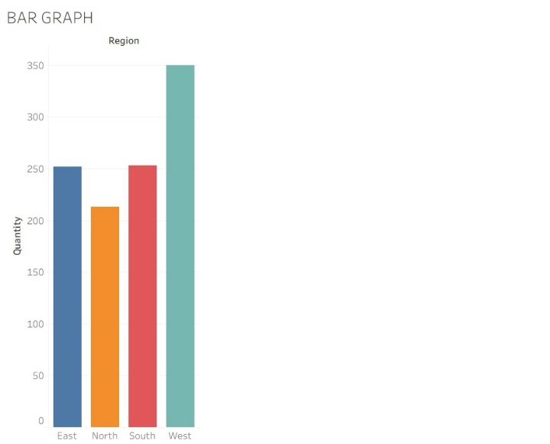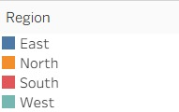
3.2.1-sum of quantity sold by region
- The West region leads in sales volume, with the highest quantity of artificial jewelry sold compared to other regions.
- The South region follows closely behind, showing strong sales performance.
- The East region maintains moderate sales, outperforming the North region but trailing behind South and West.
- The North region has the lowest quantity sold, indicating potential for growth or need for targeted marketing efforts.

- LINE CHART –

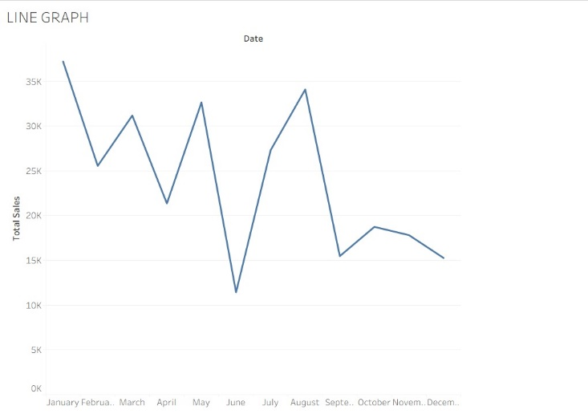
3.2.2-sales trend over months

The sales trend shows significant fluctuations throughout the year. January records the highest sales, followed by notable peaks in May and August, indicating strong demand during these months. However, there is a sharp decline in sales in June, which could be due to seasonal factors or market conditions. After August, the sales gradually decrease, showing a downward trend towards the end of the year. This pattern suggests that while certain months experience high sales activity, there may be a need to boost marketing or promotions during the slower months to maintain steady revenue throughout the year.

- PIE CHART –

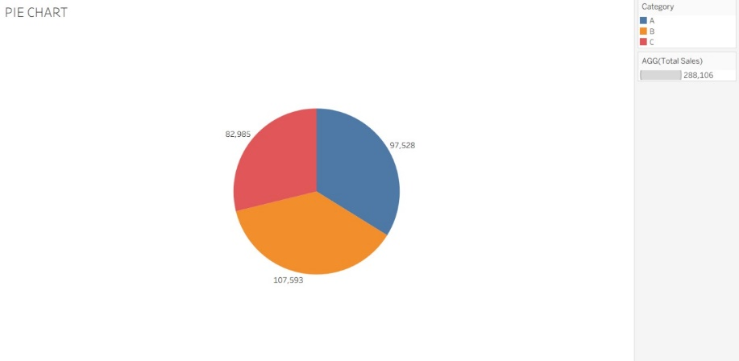
3.2.3-sales distribution by category

• Category B has the highest sales with 107,593 units, indicating strong customer demand.
• Category A follows with 97,528 units, contributing significantly to overall sales.
• Category C records the lowest sales at 82,985 units but still maintains a considerable share.
• The sales distribution suggests focusing marketing and inventory efforts more on Category B to maximize revenue.

SCATTER CHART-
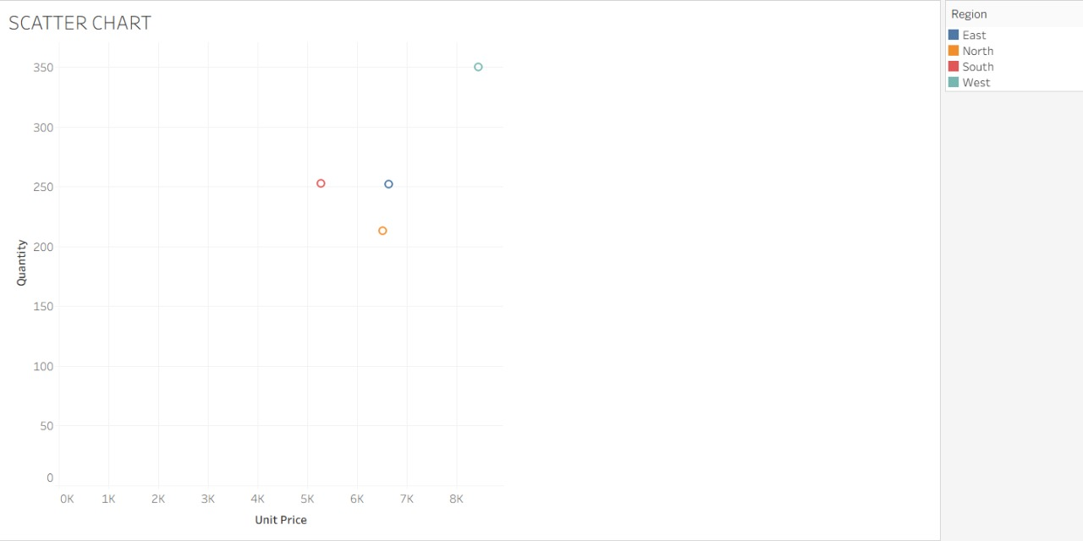
3.2.4-unit price VS category

• The West region has the highest quantity sold at the highest unit price, indicating strong demand despite premium pricing.
• The South region shows moderate quantity with a slightly lower unit price, suggesting a balanced sales approach.
• East and North regions have similar unit prices but differ slightly in quantity, with East having a bit higher sales volume.
• Overall, there is a positive correlation between unit price and quantity sold, with regional variations in purchasing behavior.

- TOTAL SALES
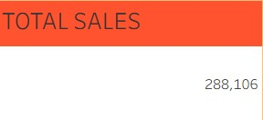
3.2.5-TOTAL SALES

The total sales value of 288,106 indicates the overall revenue generated from the artificial jewelry business during the specified period. This figure reflects the cumulative income from all transactions, highlighting the scale and market demand for the products. It serves as a key performance indicator, providing insights into business growth and effectiveness of sales strategies. Monitoring total sales helps in setting realistic targets, evaluating past performance, and making informed decisions for future planning and expansion within the competitive artificial jewelry market.

- AVERAGE DISCOUNT
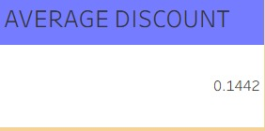
3.2.6- AVERAGE DISCOUNT

The average discount of 0.1442 indicates that customers received an average discount of approximately 14.42% on their purchases. This reflects the pricing strategy used to attract buyers and stay competitive in the artificial jewelry market. Offering this discount level can help boost sales volume while balancing profitability. Tracking average discounts helps the business evaluate the effectiveness of promotional campaigns and ensures discounts are aligned with overall revenue and profit goals.

- RETURN RATE
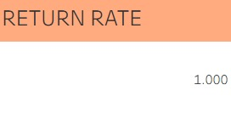
Table 3.2.7 – Return Rate
A return rate of 1.000 indicates that all products sold in this period were returned. This unusually high return rate suggests potential issues with product quality, customer satisfaction, or order fulfillment. It highlights the need for a thorough review of product standards, return policies, and customer feedback to identify root causes and implement improvements. Addressing these challenges is critical to reducing returns, improving customer trust, and enhancing overall business performance in the artificial jewelry sector.
- PROFIT
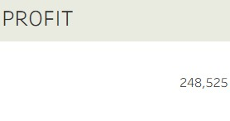
Table 3.2.8 – Profit
The profit value of 248,525 indicates a strong financial performance in the artificial jewelry sales. This positive profit margin suggests effective cost management and successful sales strategies, reflecting a healthy business operation. Maintaining and further improving profitability will be key to sustaining growth and competitiveness in the market.

4. FINDINGS & OBSERVATION

FOR TABLEAU:
4.1- Dashboard with tables and charts, outcomes
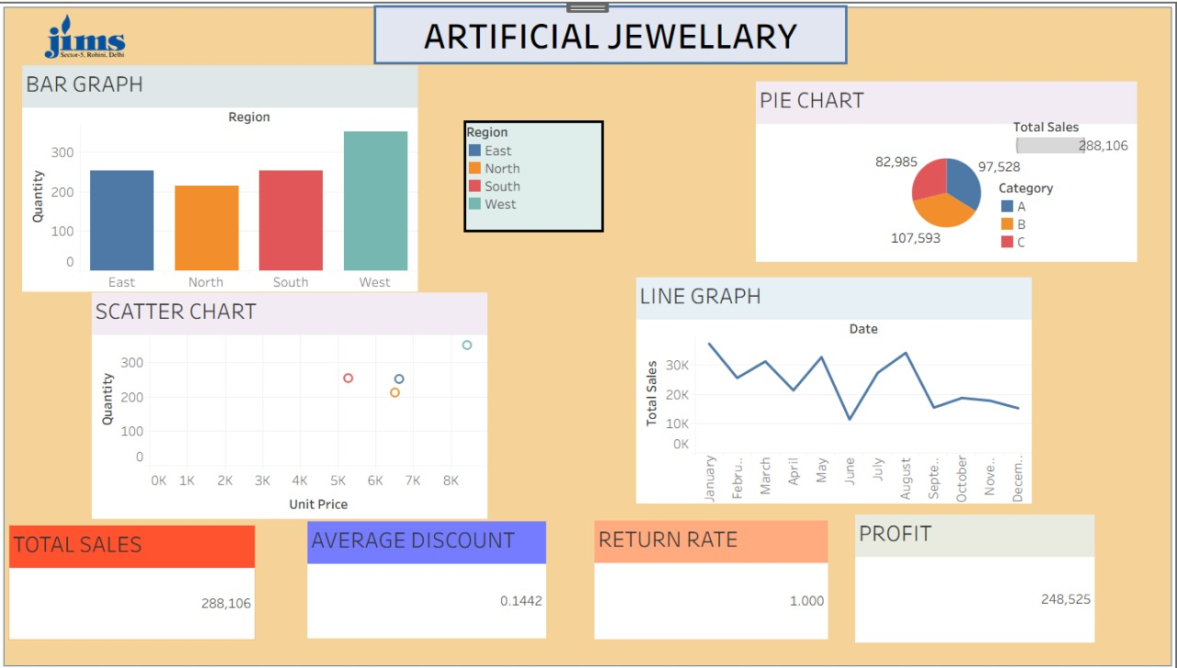

Figure 4.1.1 - Tableau dashboard for measures and charts

This dashboard of an e-commerce online system presents four key measures:
- Total sales (288,106)
- Average Discount (0.1442)
- • Return Rate (1000)
- Profit (248,525).
The dashboard includes multiple charts for better insights:

1.Bar Graph – Quantity by Region
- Purpose: Compares the number of units sold in each region (East, North, South, West).
- Insight:
  - The West region has the highest sales quantity, indicating strong demand.
  - The North region has the lowe1st, suggesting potential for improvement or lower market reach.
  - Helps identify which geographic areas are performing better in terms of quantity sold.

2. Pie Chart – Sales by Category
- Purpose: Displays the percentage of total sales from each product category (A, B, C).
- Insight:
  - Category B leads in total sales, followed by A, then C.
  - Indicates customer preference or popularity of products in different categories.
  - Useful for product planning, inventory focus, and marketing strategy.

3. Scatter Chart – Unit Price vs Quantity by Region
- Purpose: Shows the relationship between unit price and quantity sold for each region.
- Insight:
  - The West region sells the highest quantity at the highest price, a strong indicator of product acceptance.
  - Other regions show more balanced or lower values.
  - Helps assess price sensitivity and market potential across regions.

4. Line Graph – Monthly Sales Trend
- Purpose: Tracks total sales over the months (January to December).
- Insight:
  - Sales peak in January, May, and August, indicating potential festive or seasonal demand.
  - June and December see the lowest sales, requiring targeted strategies.
  - Reveals seasonal trends and helps in planning promotions or stock.
.
Each chart and measures are interactive and navigates to its respective detailed sheet for deeper analysis. The JIMS logo at the top is hyperlinked to the official JIMS website.
Overall, the system demonstrates healthy growth, with certain regions and categories driving performance, while also indicating opportunities for strategic pricing and regional sales enhancement.

CONCLUSION AND RECOMMENDATION

5.1 - Summary Of Learning
The healthcare patient record analysis provided valuable insights into service delivery, patient behavior, and financial performance. Key findings include:
• Understood how to analyze artificial jewellery sales data to identify key business trends and performance indicators.
• Gained insights into regional performance, learning that the West region had the highest quantity sold, indicating strong market potential there.
• Learned how to evaluate sales trends over months, helping to identify peak-selling periods and low-demand months for better inventory and marketing planning.
• Analyzed category-wise performance through pie charts, which helped determine that Category B generated the highest sales among all.
• Interpreted relationships between unit price and quantity sold using scatter charts to assess pricing strategies across regions.
• Strengthened skills in working with key business metrics such as total sales (₹288,106), average discount (0.1442), return rate (1.000), and profit (₹248,525).
• Learned the significance of visual dashboards in summarizing complex data and presenting insights clearly for decision-making.
• Developed the ability to make data-driven recommendations for improving product strategy, regional focus, and customer satisfaction.

Recommendations:
• Focus on the West Region: Since the West region has shown the highest quantity sold, more marketing and inventory allocation should be targeted here to boost revenue further.
• Optimize Product Category B: Category B leads in total sales; therefore, expanding the variety within this category and promoting it more could enhance overall profitability.
• Review Return Policies: With a return rate of 1.0, there may be issues with product quality, customer expectations, or logistics. Investigating return reasons and improving quality assurance is crucial.
• Strategic Discounts: An average discount of 14.42% has still resulted in good profit margins. Targeted discount strategies can be implemented during low-sales months to stimulate demand.
• Boost Sales During Low Months: The sales trend graph shows a dip in June and December. Seasonal promotions, festival offers, or influencer marketing could help improve sales during these months.
• Use Data for Forecasting: Apply predictive analytics using past trends to forecast future demand and manage stock levels more effectively.
• Customer Feedback Loop: Collect and analyze customer feedback, especially for returned products, to improve product designs and customer satisfaction.
• Product Bundling Strategy: Consider bundling fast- and slow-moving jewellery items together to move inventory more efficiently.

5.3 – Suggestion For Future Work

• Expand the dataset to include multiple years of sales data to analyze long-term trends and growth patterns in artificial jewellery.
• Incorporate customer feedback and return reasons to better understand product-related issues and improve overall quality and satisfaction.
• Include additional product attributes such as material type, design style, or color to gain more detailed insights into customer preferences.
• Introduce sales channel analysis (e.g., offline vs. online) to understand where most purchases are made and how to allocate resources accordingly.
• Apply predictive analytics to forecast sales trends during festivals or peak seasons, improving inventory and marketing planning.
• Study customer segmentation to target different groups with personalized offers and improve conversion rates.
• Conduct price sensitivity analysis to determine optimal pricing strategies for various categories and regions.
• Evaluate the impact of marketing campaigns or discounts on overall profit margins to improve promotional effectiveness.
• Integrate inventory and supply chain data for a more complete view of operational efficiency and cost control.

REFRENCES:
- Sharma, R., & Gupta, M. (2022). Trends in Artificial Jewellery Market in India. International Journal of Business and Management Research, 10(3), 45–52.
- Singh, A. (2021). Consumer Buying Behavior Towards Fashion Jewellery in Urban India. Journal of Retail and Marketing, 8(2), 101–110.
- Statista. (2024). Fashion Jewelry Market Size Worldwide. Retrieved from https://www.statista.com
- Ministry of Commerce & Industry, Government of India. (2023). Annual Export Report – Gems & Jewellery Sector. Retrieved from https://commerce.gov.in
- Power BI Documentation. (2024). Create and Share Interactive Dashboards. Microsoft Docs. Retrieved from https://learn.microsoft.com
- Tableau Software. (2025). Tableau help. Tableau Documentation. Retrieved from https://help.tableau.com

ANNEXURE

- Raw Data/questionnaire
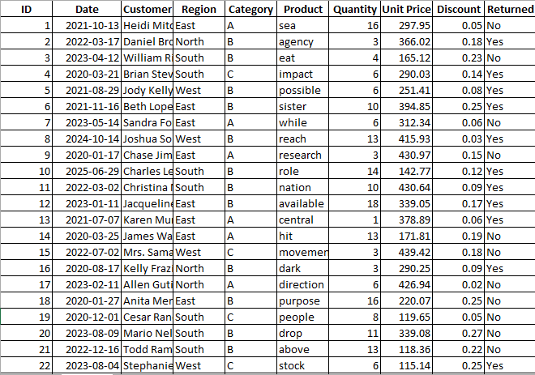
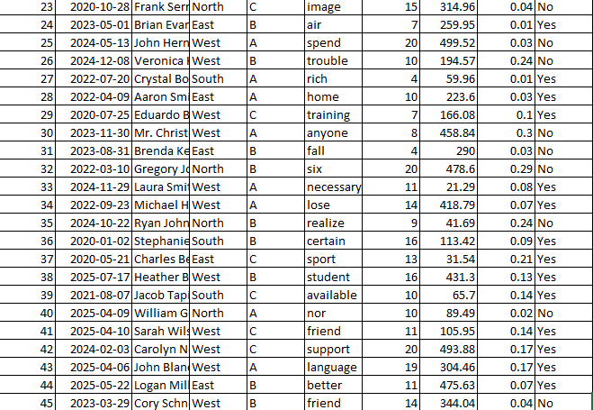
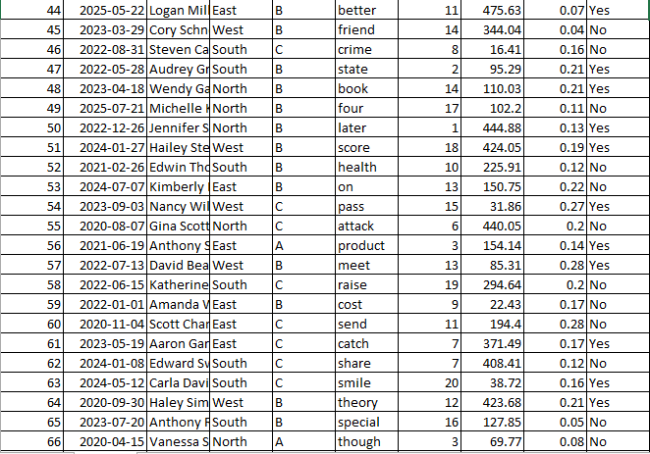
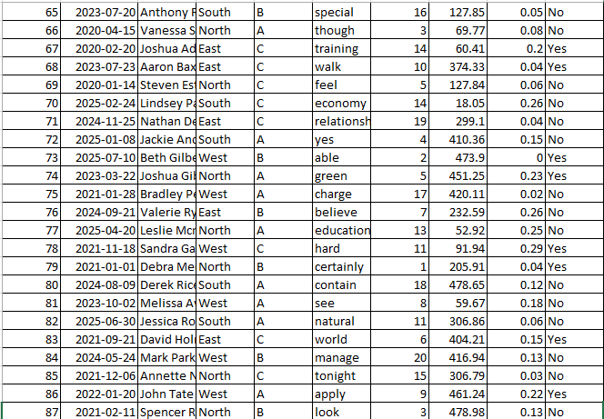

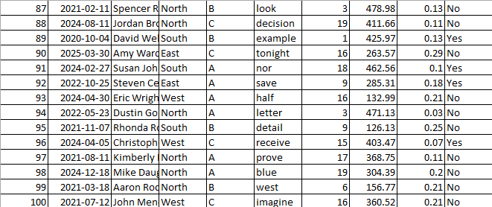

- Screenshot of work


